**PVKN GOVT COLLEGE (A), CHITTOOR**

**DEPARTMENT OF COMMERCE**

**NATIONAL CONSUMER DAY-2024**

**Topic: Virtual Hearing and Digital Access to Consumer Justice**

**వర్చువల్ హియరింగ్ మరియు వినియోగదారుల న్యాయానికి డిజిటల్ యాక్సెస్**

**Date:24-12-2024**

**Objectives:**

1. To give awareness to students on consumer rights
2. To motivate the students to know the rights of consumer
3. To identify the common problems of consumers and remedies and suggestions and solutions.
4. To encourage the students to know on Digital Access to Consumer Justice

The Department of Commerce organized National Consumers day awareness programme on 24 December 2024. Chaired by Trainee collector D. **Hima Vamsi**, DSO: Shankaran, and District Consumer Forum Member Saleem are participated in programme. National Consumer Day, celebrated on December 24 every year, is a national event that aims to raise awareness about consumer rights and needs. Consumer rights mean that every person who buys various products, goods, and services, has the right to have information on the quality, purity, price, and standard of those products. Did you know that you have the right to file a complaint from anywhere, anytime as a consumer? Most people are not aware of their rights as consumers, so by celebrating this day, we make others aware of the right to demand protection and stay safe from fraudulent activities in the marketplace.

National Consumer Rights Day has been celebrated since 1986, and the date of December 24 honors the speech made by the president. The Consumer Protection Act was approved by the President of India on December 24, 1986. Right to Choose : Consumers should have access to a variety of goods and services at competitive prices

In Celebration of National consumer day The Department of commerce organised District level Elocution and Essay writing Competition in Telugu and English on 19-12-2024 at 10am to 12 pm.

**PVKN GOVT. COLLEGE A CHITTOOR   
Department of Commerce**NATIONAL CONSUMER DAY - 2024

District level competition

**WINNERS LIST**

**ESSAY WRITING :**

**TOPIC: VIRTUAL HEARINGS & DIGITAL ACCESS TO CONSUMER JUSTICE**

|  |  |  |  |  |
| --- | --- | --- | --- | --- |
| **WINNERS** | **Name of the students** | **Name of the college** | **Group** | **Mobile No** |
| 1st prize | R. Madhupriya | PVKN GC A Chittoor | II BSC Chemistry | 8885234233 |
| 2nd Prize | V. Lalitha | PVKN GC A Chittoor | II B.Com CA | 8977557025 |
| 3rd Prize | K. Karthikeya | PVKN GC A Chittoor | II BSC Physics | 9030952238 |

**TOPIC: వర్చువల్ హియరింగ్‌లు & వినియోగదారుల న్యాయానికి డిజిటల్ యాక్సెస్**

|  |  |  |  |  |
| --- | --- | --- | --- | --- |
| **WINNERS** | **Name of the students** | **Name of the college** | **Group** | **Mobile No** |
| 1st prize | S. Anjuma | NPS GC A (W), Chittoor | I B.Com CA | 8074007116 |
| 2nd Prize | K. Munirathnam | PVKN GC A Chittoor | II BSC Maths | 7095501064 |
| 3rd Prize | B. Dileep | PVKN GC A Chittoor | II B.Com CA | 8074277018 |

**ELOCUTION :**

**TOPIC: VIRTUAL HEARINGS & DIGITAL ACCESS TO CONSUMER JUSTICE**

|  |  |  |  |  |
| --- | --- | --- | --- | --- |
| **WINNERS** | **Name of the students** | **Name of the college** | **Group** | **Mobile No** |
| 1st prize | K. Varsha | NPS GC A (W), Chittoor | I B.Com CA | 8317489539 |
| 2nd Prize | M. Yaswini | PVKN GC A Chittoor | II B.Com CA | 8125878196 |
| 3rd Prize | S. Faimunnisa | NPS GC A (W), Chittoor | I B.Com CA | 7893387850 |

**TOPIC: వర్చువల్ హియరింగ్‌లు & వినియోగదారుల న్యాయానికి డిజిటల్ యాక్సెస్**

|  |  |  |  |  |
| --- | --- | --- | --- | --- |
| **WINNERS** | **Name of the students** | **Name of the college** | **Group** | **Mobile No** |
| 1st prize | V. Lalitha | PVKN GC A Chittoor | II B.Com CA | 8977557025 |
| 2nd Prize | S.Anjuma | NPS GC A (W), Chittoor | I B.Com CA | 8074007116 |
| 3rd Prize | N. Kusuma | NPS GC A (W), Chittoor | I BBA | 9701569325 |

Conducted Elocution and Essay writing:

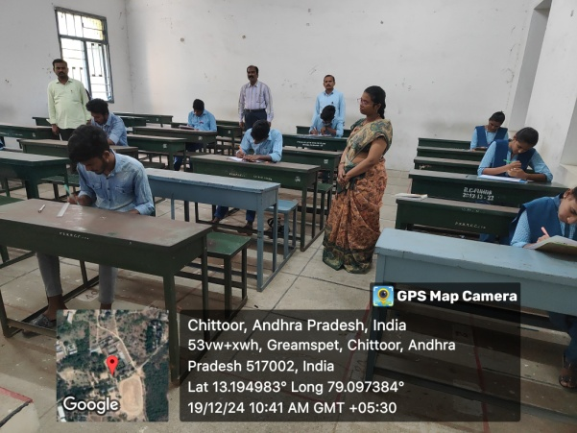 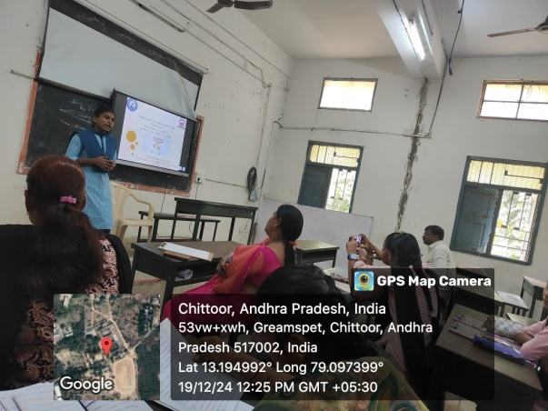

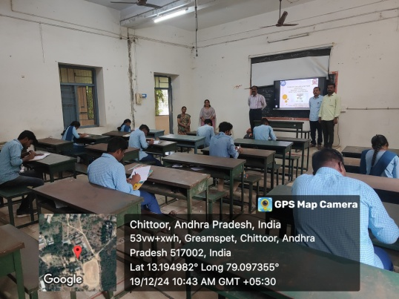 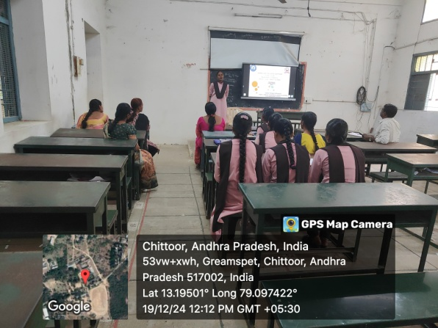

**Paper Clippings**

 

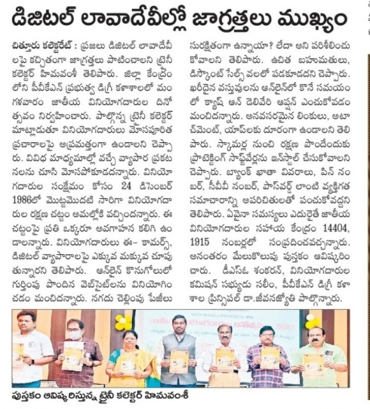 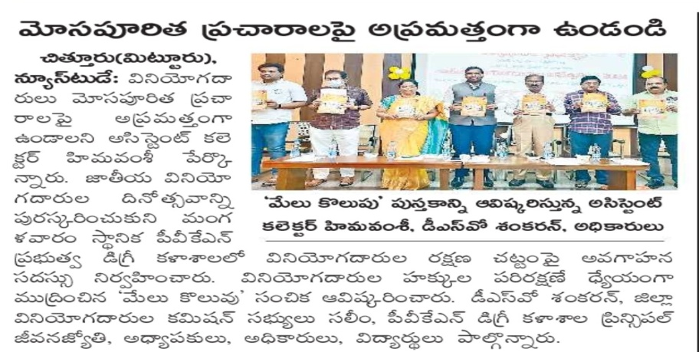

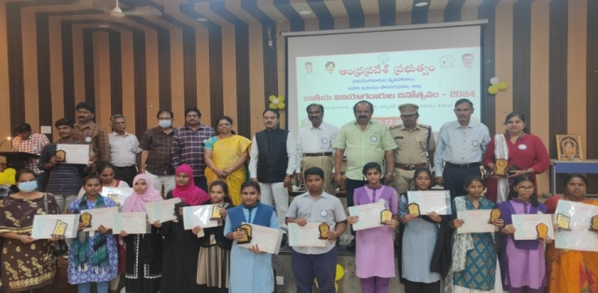 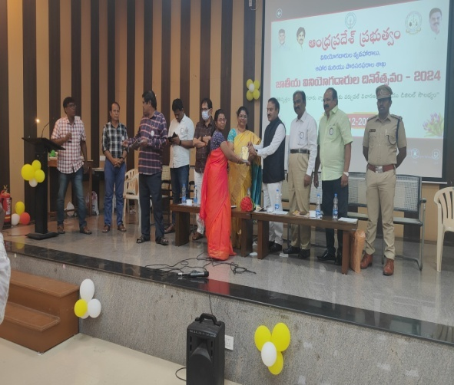

Prize winners on Essay Writing and Elocution by the students

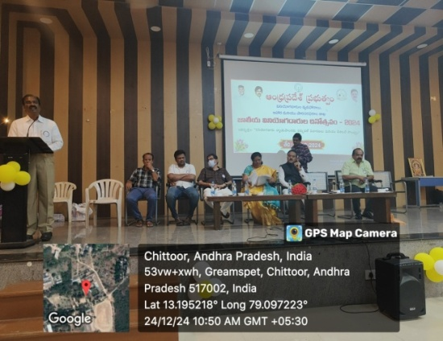 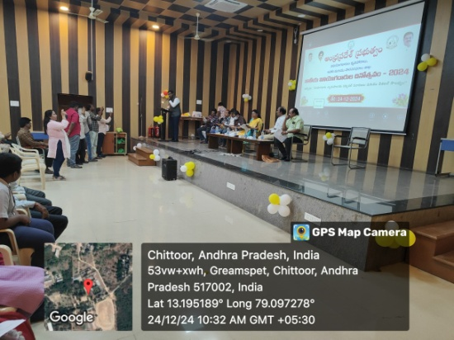

Teaching staff , Public reporters and students

**Conclusion:** All the eminent officer’s are highlighted the consumers rights and problems which are facing daily life. All the conusmer’s must take bills which they Perform buying their products and the consumer must care in digital finance which is transferable in Paytm , Phonepe and Google pay and about Virtual Hearing and Digital Access to Consumer Justice